**Assignment -3**

News Tracker Application – Connect to IBM Cloud Object and create a chatbot in IBM Watson

Assistant

|  |  |
| --- | --- |
| Assignment Date | 14 October 2022 |
| Student Name | ASWANTH R |
| Student Roll Number | 953719104010 |
| Maximum Marks | 2 Marks |

**Question-1:**

1.Create a Bucket in IBM object storage.

2.Upload 5 images to IBM object storage and make it public. Write html code to displaying all the 5 images.

3.Upload a CSS file to the object storage and use the same CSS using external link in your HTML page.

4.Design a chatbot using IBM Watson assistant for hospital. Ex: User comes with query to know the branches for that hospital in your city. Submit the web URL of that chat bot as an assignment.

5.Create Watson assistant service with 10 steps and use 3 conditions in it. Load that script in HTML page.

**Solution:** \*\***All the required files are uploaded in the Assignments/Aswanth R (Team Lead)/Assignment 3 folder in the Git repo. Please verify it sir/mam.**

**Step 1**: Create a Bucket in IBM object storage. **Step 2**: Upload 5 images to IBM object storage and make it public. Write html code to displaying all the 5 images. **Step 3**: Upload a CSS file to the object storage and use the same CSS using external link in your HTML page.

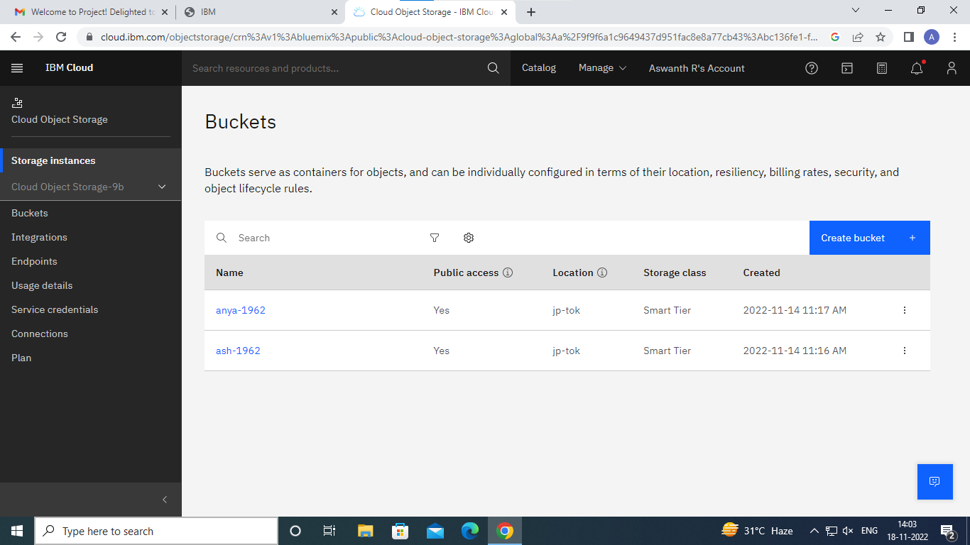

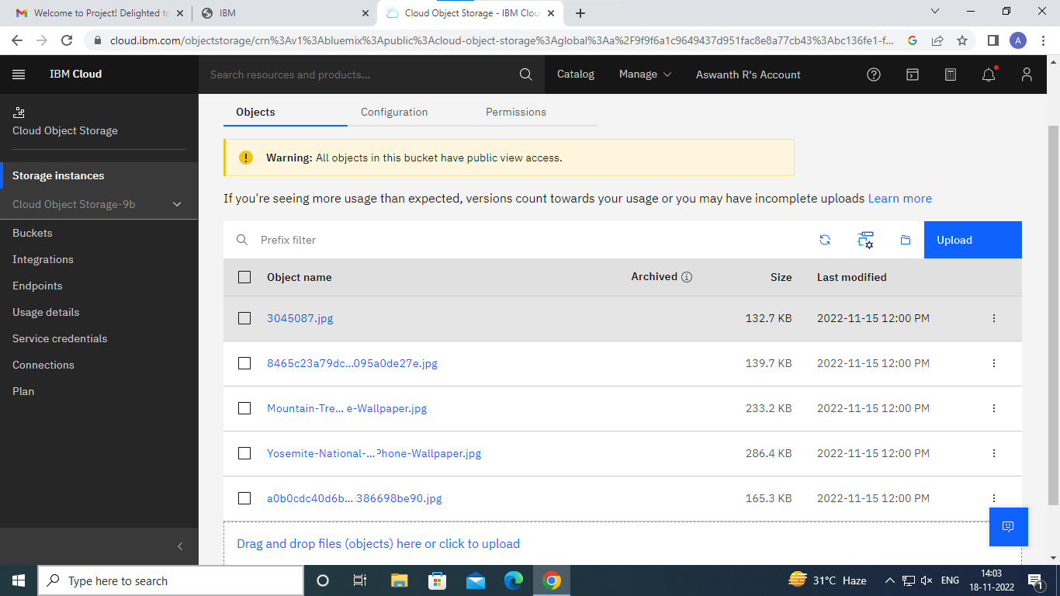

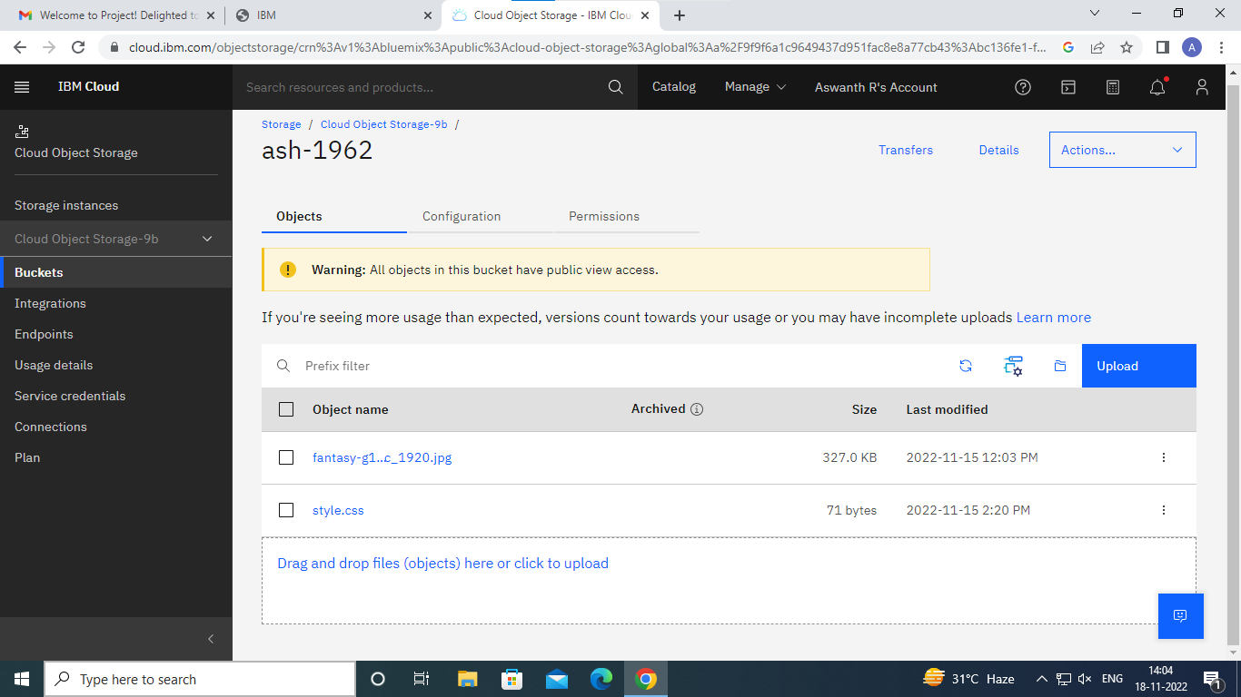

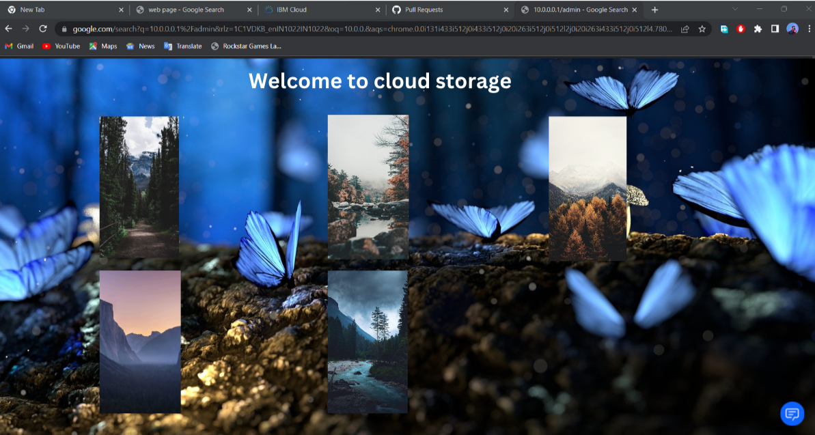

**Step 4**: Design a chatbot using IBM Watson assistant for hospital. Ex: User comes with query to know the branches for that hospital in your city. Submit the web URL of that chat bot as an assignment.

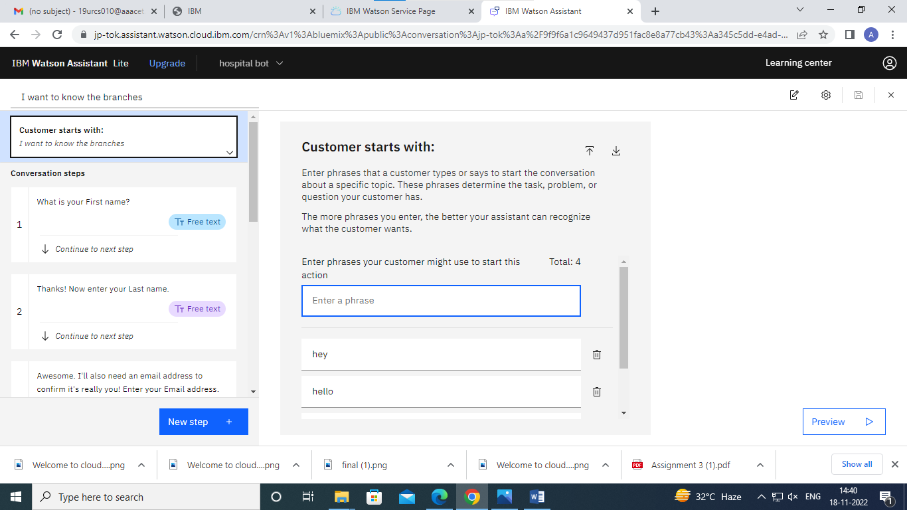

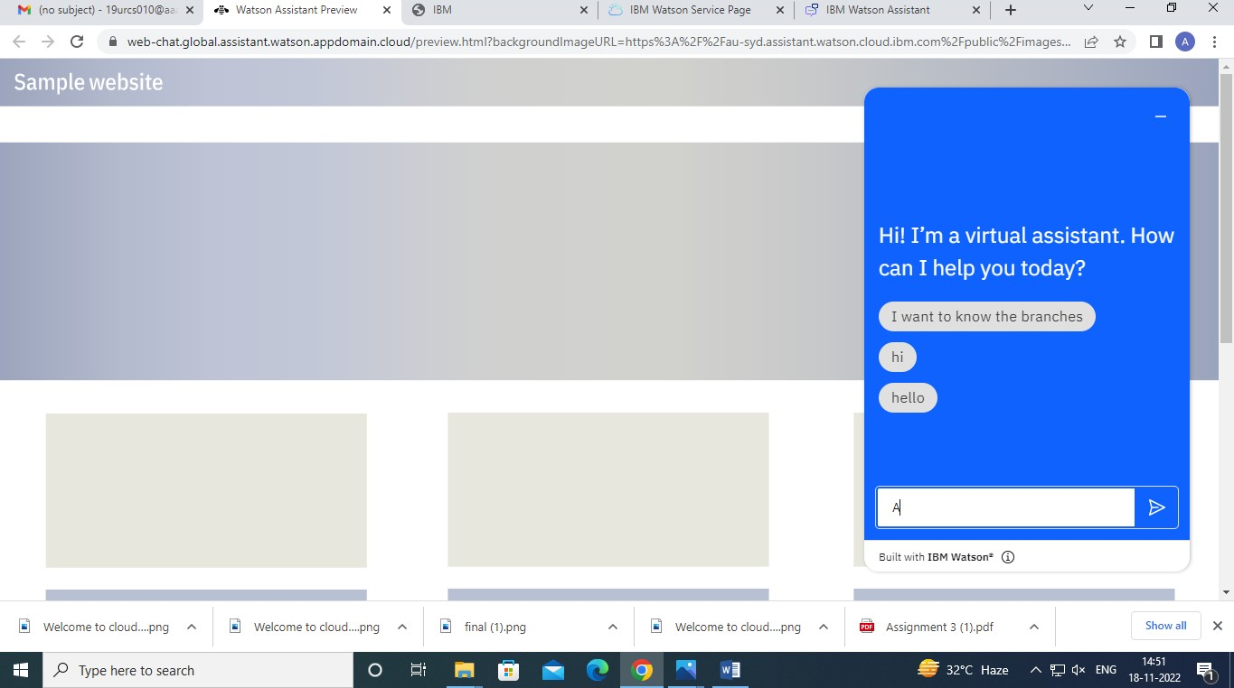

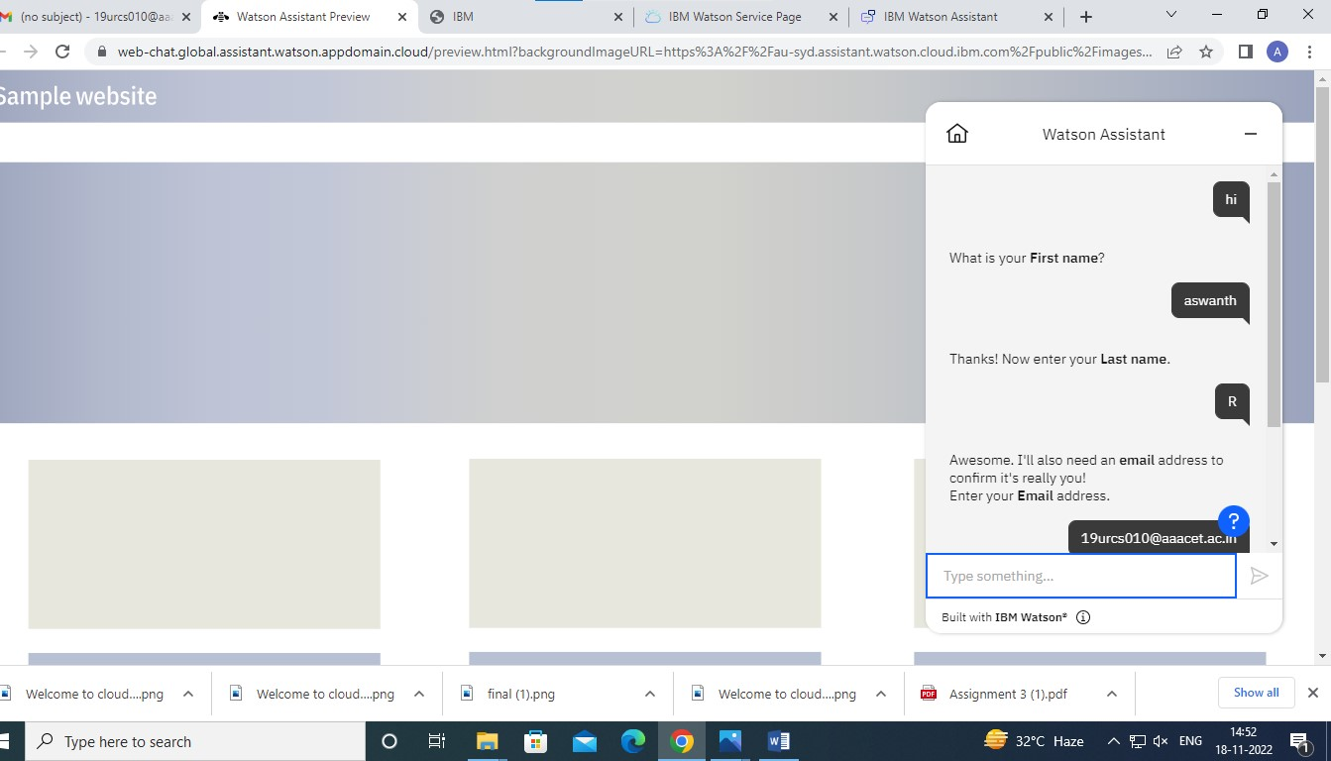

Chat Bot Web url:

https://webchat.global.assistant.watson.appdomain.cloud/preview.html?backgroundImageURL=https%3A%2F%2Fjp-tok.assistant.watson.cloud.ibm.com%2Fpublic%2Fimages%2Fupx-a345c5dd-e4ad-4ab3-a263-77a18a0ed62e%3A%3A63e9f874-56d7-49ea-bd57-56f8bf19ece0&integrationID=52071966-35b6-4103-a926-34b2fddd47f7&region=jp-tok&serviceInstanceID=a345c5dd-e4ad-4ab3-a263-77a18a0ed62e

**Step 5**: Create Watson assistant service with 10 steps and use 3 conditions in it. Load that script in HTML page

